**APPLICATION AREAS OF 3D INTERNET**

**BY**

**BENARD SALVATION**

**ST/CS/ND/18/362**

**A SEMINAR PRESENTED TO THE DEPARTMENT OF COMPUTER SCIENCE, SCHOOL OF SCIENCE AND TECHNOLOGY, MUBI, ADAMAWA STATE, NIGERIA**

**FEBRUARY, 2021**

**ABSTRACT**

*The seminar covers contents such as introduction of 3D internet and network, application areas of 3D Internet, its features and components, working of 3D internet, technical implementation, problem statements, why we need 3D internet, diagrammatical expression of 3D internet and its advantage and disadvantages.*

**1.0 INTRODUCTION**

Like existing internet, 3D internet is a set of interconnected virtual worlds that users can visit to consume services, teleporting from one world to another

P. Patil, ‘3D Internet', 2013.3D internet is a powerful combination of two forces. Those two forces are Internet and 3D Graphics.  The 3D Internet is inherently interactive and engaging. Like 2D internet it will use Browser, Search engine, Servers. As compare to 2D Internet, it will make world more social.

## APPLICATIONS OF 3D INTERNET:

1. Education.
2. Religious.
3. Embassies.
4. 3D in art creation.
5. Real Estate.
6. Social Interaction.
7. Tourism
8. Entertainment
9. E-commerce

**Education:** By implementing 3D Internet in education, people can have a better understanding of the subject. They can view lectures and experiments in a 3D manner that will help them learn more efficiently than the traditional approach. One such example can be that the Medical professionals can view operations in 3 dimensions, distance education will be valued, illustrative and demonstrative tutorials shall be more effective.

**Religious:** Religious organizations can make use of the 3D Internet to open virtual meeting places within specified locations.

**Embassies:** We could create embassies in 3D Internet, where visitors will be able to talk face- to-face with a computer-generated ambassador about visas, trade and other issues.

**Live sport entertainment:** Popular forms of live entertainment could also be placed into the 3D Internet. Many sports allow the users to watch or participate in many popular activities. Sporting leagues like Cricket, Football, Professional Wrestling, boxing, and auto racing could be placed in the 3D Internet for its users to play in the 3D environment

**3D in Arts creation:** The modeling in 3D Internet would allow the artists to create new forms of art, that in many ways are not possible in real life due to physical constraints or high associated costs. In 3D Internet artists could display their works to an audience across the world. This has created an entire artistic culture on its own where many residents who buy or build homes can shop for artwork to place there.

**Real Estate:** 3D Internet can drastically change the real estate industry. Customers can view the property they are interested in online with a stereoscopic view. They will get a basic idea of the area and locality they are going live in even before its complete construction. This will ease the selection process of property to a great extent.

**Social Interaction:** The current generation has a much more active online social life as compared to real life. Addition of 3D to social networking can revolutionize our digital world. Video calls can be more interactive and appealing. 3D chat spaces can be introduced to social media. Personal interaction won't be limited to real world. People unable to meet on regular basis can interact online.

**Tourism**: It is important to choose the right destination to spend holidays which can be much easier after the implementation of 3D Internet. Tourists can have a sample 3D view of the desired locations and later decide which destination has to be visited. They can have a short demo of the place they are about to visit and decide if it’s worth investing on the trip.

**Entertainment:** Online 3D games, 3D movies, etc. won't be a dream anymore. All this can be achieved using 3D Internet. Users won't be compelled to go to a multiplex for experiencing a 3D movie. Gamers can enjoy 3D online games at home and can easily connect with their friends. Live action sports will be more interesting

**E-commerce:** Online Shopping can be more realistic and reliable with the employment of 3D Internet. Concept like Online Shopping Malls and Stores can be implemented so that the users can visit virtual malls from Internet. Vicarious feeling of shopping can be fulfilled by consumers by sitting at home. It will be a benefit to both, the buyer and the seller as the basic necessity to meet at a common trading place will be eliminated completely while the shopping experience will remain intact.

**Culture:** 3D Internet will open gates to art forms that don't exist at today's date. Artists can portray their artwork to the whole world in an entirely new fashion. Just as 2D art has a ton of different forms such as paintings, drawings, photography, mixed media, craft, etc. 3D art will also create a new genre of creative forms, something that can't be imagined as of now due to the absence of a 3D platform and human brain's limited scope to 2D imagination.

**1.3 3D INTERNET FEATURES**

One of the best features of 3D internet is that it also supports 3D internet TV. New technology for 3D TV that is 3D internet TV and HDTV 3D internet TV Wi-Fi.

Sumalatha & Bharathiraja, (2013).In such TVs internet connectivity will be built up in TV via Wi-Fi. The picture and graphic quality will also be tremendously improved along with a lot of TV channels that is building in internet connectivity with 3D TV, to improve quality and to increase number of channels that user may access.

With Such internet 3D TV, it will also be possible to enjoy other services on TV such as Skype.

**1.4 3DINTERNET COMPONENTS**

Abram, Cleo (8 January 2020). Though the technology and components used for 3D internet are same as used in traditional internet also it interacts with the same servers and search engines. But being more social 3D internet is different from traditional 2D internet.

The wonderful thing about 3D internet is that participants learn as much from each other as from talking to any official source of information. 3D internet search is also as advanced as it opens a vast array of possibilities when it comes to search and browse data.

Through 3D internet multi users can read the same documents. You connect organically with other people that share your interests and access the same service as other use. People can also watch online 3D movies via internet with no buffering time.

3D internet also offers other facilities like virtual meetings, support groups, academics, training chats and shopping.

## WORKING OF 3D INTERNET

1. It works by using virtual platform.
2. By using artificial Intelligence.
3. By using eye wear like Google glass.
4. By using sensors and holographic image projection.

**1.6 TECHNICAL IMPLICATION**

**Speed:** Internet speed is one of the most significant implications that are being faced by the 3D Internet. A research shows that not many countries in the world are in a state to fulfill the internet speeds that are required for the implementation of the 3D Internet. Here, in the below chart we can see the average broadband speed in various countries.

**Hardware:** Hardware implications are not quite serious implications to be thought of because the main Hardware implication that we face to implement the 3D Internet is that the display device used to display the images are 2D in nature, but with the inclusion of the 3D internet there would be great difficulty to view the 3D objects in the 2D devices.

**1.7 VIEW OF THE EXISTING WEB**

Mr. S. Sumalatha. Mr. S. Bharathiraia, E. (2013). Getting a glimpse of the next generation internet and knowing its seamless power.

**WEB 1.0:**

1. First face of the World Wide Web.
2. Edited only by webmasters.
3. Similar to a hand-written notebook.
4. Threatened to paranoid perception.

**WEB 2.0:**

1. Everyone can contribute to the web.
2. Rich user interface and best in class graphics.
3. 85% majority websites in web 2.0.
4. Change is inevitable.

**WEB 3.0:**

1. Use of metaverse in web technology.
2. The rise of intelligent systems.
3. Birth of the most awaited future internet.
4. Webpages and Webplaces.

**3D INTERNET: WHY?**

Castells, (2010). One of the often heard arguments against the 3D Internet is in the form of the question “why do we need it?” For most of its users the Internet is a familiar, comfortable medium where we communicate with each other, get our news, shop, pay our bills, and more.

We are indeed so much used to and dependent on its existence that we don’t think about its nature anymore just like we do not think about Ohm’s law when we turn on the lights. From this perspective what we have, i.e. the 2D version, seems “sufficient” and the 3D Internet is yet another fad.

However, if we stop and think about the nature of the Internet for a moment we realize that it is nothing but a virtual environment (cyberspace) where people and organizations interact with each other and exchange information. Once this fact is well understood, the question can be turned on its head and becomes “why do we restrict ourselves to 2D pages and hyperlinks for all these activities?”

Chun, Kogan, Kokkevis, Weber, & Petterson, (2011). Navigating hierarchical data structures is often cumbersome for large data sets. Unfortunately, the Internet as we know is organized as a flat abstract mesh of interconnected hierarchical documents. A typical 2D website is an extremely abstract entity and consists of nothing but a bunch of documents and pictures. Within the website, at every level of the interaction, the developers have to provide the user immediate navigational help.

Otherwise, the user would get lost sooner or later. Since this is a very abstract environment, there is no straightforward way of providing a navigation scheme which would be immediately recognizable to human beings. The situation is not any better when traveling between websites. It is no surprise that Google is the most powerful Internet Company of our times.

Figure: 1 working space of 3D internet

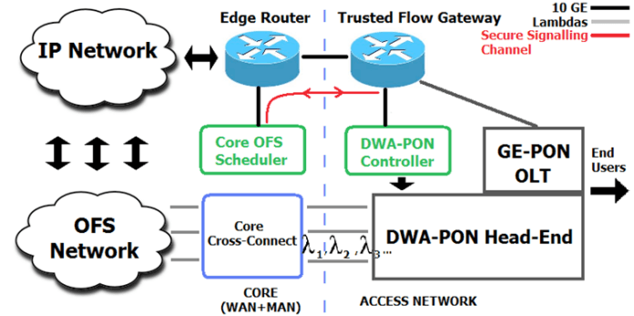

Figure: 1 the above illustration diagram shows the working modalities and the necessary requirement for a workable 3D internet network.

Figure: 2 Google's new three dimensional virtual reality.



Figure: 2 Google's new three dimensional virtual reality: anyone putting on "the Googgles" - as the insiders call them - will be immersed in a three dimensional "stereo-vision" virtual reality called 3DLife. 3DLife is a pun referring to the three dimensional nature of the interface, but also a reference to the increasingly popular Second Life virtual reality.

Figure: 3 the evolution of the internet

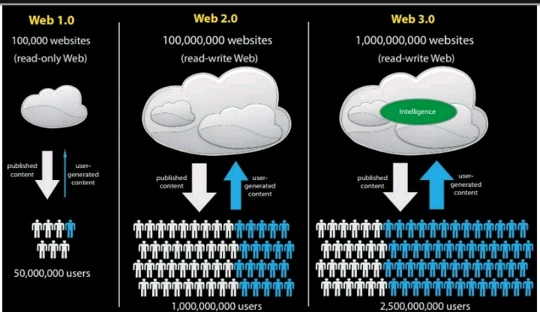

Figure: 3 above showing the evolution of the internet from web 1. 0, web 2.0 and web 3.0 and the numbers of users that can gain access at a time.

Figure: 4 Nature of 3D internet

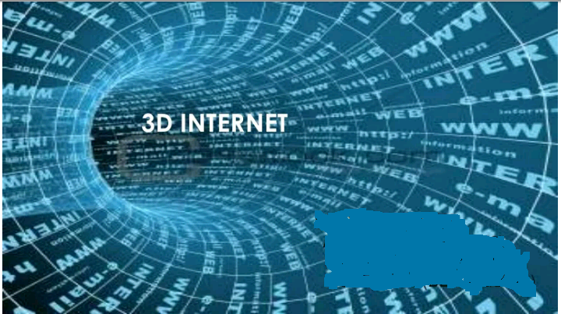

Figure: 4 the diagram above is showing the speed of the 3D internet

**Advantage of 3D internet**

1. More interactive
2. Reduce mouse movement
3. Simple effective representation
4. Increased speed of working
5. Participants have control throughout the virtual space
6. Content is readily available
7. Participants have a choice in weather to interact with an offering

**Disadvantage of 3D internet**

1. Requires high internet speed
2. Difficulty in viewing 3D object in 2D Display Device
3. Difficult in modeling, High cost
4. Lack of an effective way for enabling people in virtual world
5. The limited effectiveness of traditional media technics.

**CONCLUTION**

Virtual worlds provide immersive 3D experiences that replicate (and in some cases exceed) real life. People who take part in virtual worlds stay online longer with a heightened level of interest.

**RECOMMENDATION**

3D Internet can be used as a platform for education by many institutions, such as colleges, universities, libraries and government entities especially during a crucial periods during pandemic.

We can see that 3D Internet Technology is the future as it will surely change the way we perceive Internet today. The advantages and applications clearly surpass the cost associated with the implementation. The need of a ubiquitous and intelligent Internet can surely be fulfilled by 3D Internet. Businessmen and interested investors are aware of the true potential of the user friendly, interactive, productive and addictive market side of it. But due to many obstacles like Internet bandwidth, hardware, cost factors and lack of research it isn't easy to implement.

At this point the society has the capability to evolve the digital world to a much more versatile and intriguing version but it does need a lot of research and the required financial support for becoming a reality.

**REFRENCES**

Abram C. (2020). “How does the Internet work?” Source: http://www.slideshare.net/prasadpa3954/how does the internet work-12336161

Castells M. (2010). The Rise of the Network Society. Wiley. ISBN 9781405196864

Chun U., Kogan D., Kokkevis V., Weber N., Petterson R., et al.(2011) Google body: 3d human anatomy in the browser. In: ACM SIGGRAPH 2011 Talks. ACM. ISBN 1450309747; 2011, p. 19.

Sumalatha G. & Bharathiraja E. (2013). “A survey on 3d Internet in web 3.0”. IJECS volume 2 issue 3 March 2013 pg. 593-598.

Patil P., (2013) ‘3D Internet', Slideshare.net, 2013. Source: <http://www.slideshare.net/prasadpa3954/3d-internet-27320866>